TEESSIDE UNIVERSITY

SCHOOL OF COMPUTING

**SOFTWARE ARCHITECTURE (COM3041-N) TEAM DOCUMENTATION**

Team Name: **E**

# Architecture

Our solution uses a service orientated architecture, splitting the separate components into separate solutions that can be individually deployed and scaled when needed. Each component of the system is intended to be deployed to Azure for hosting. Since each component can be run without relying on every other component, if one component were to go down then the entire system would not be affected.

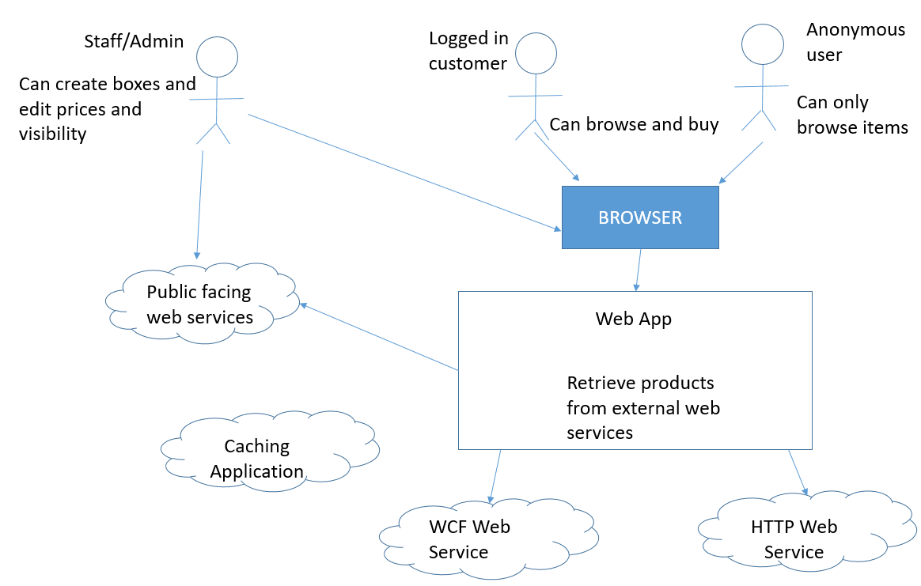

Top Level Architecture

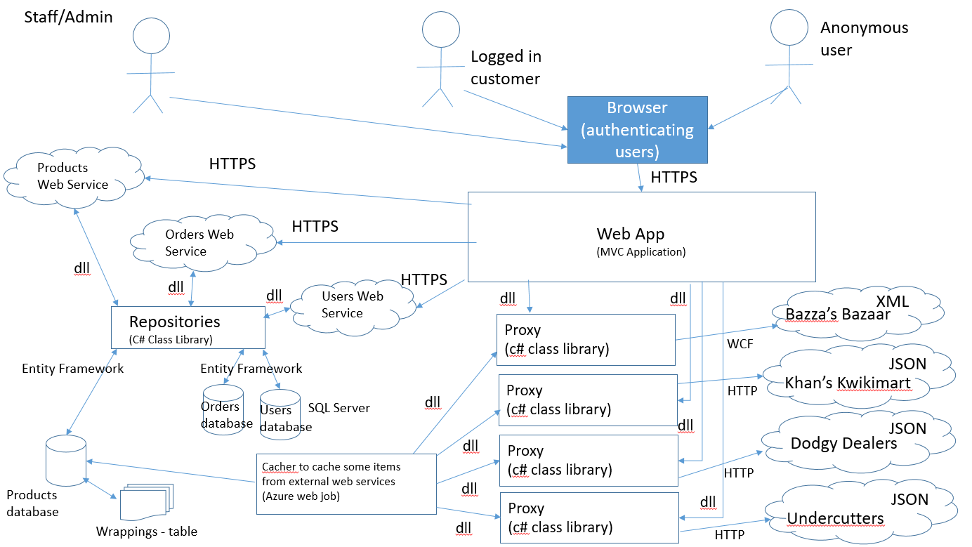

Tier 2 Architecture

For our web services and application, we will be using HTTPS as the protocol for communication, this is especially important when handling things like orders. Unfortunately, the web services for the other stores only use HTTP but this is beyond our control.

Our architecture uses a number of different databases, one for each of the services. The users database stores information on the members of staff, so if a user exists in this database then they will be able to create and edit boxes. The orders database is for storing orders of boxes. The products database stores cached products from the others stores including wrappings and details on selection boxes.

The caching application was created as we found that some of the web services provided weren’t very stable and could result in a significant decrease in performance and reliability if accessed directly. The caching application is run as a web job on Azure every hour, this makes sure that any data displayed is an hour old at the most. Initially we were just going to cache the products from the web services that caused an issue, but we then realised that it would be difficult to create a relationship between boxes and the products inside them if we were not storing all of the products.

The repository pattern is implemented to provide a layer of abstraction between the data access layer and the business logic. It separates the code that maps data from the database to DTOs and the code that is used to implement business logic such as which boxes should be displayed. By having all of the logic in the repositories it keeps the web service controllers that use them, small in size. Furthermore, if any logic needs to be changed then only the repository needs to be redeployed rather than all of the applications that use the same logic. The Repositories would be bundled with the web services when being deployed as class libraries themselves cannot be deployed.

The Proxy pattern is used to interface with the external web services such as Dodgy Dealers, Undercutters, KhansKwikiMart and Bazzas Bazaar. This allows us to take the data from those web services and convert them into a format that is suitable for our application and able to be stored in our databases. The proxies would also be included as a dll in the web application as they also cannot be deployed on their own as a class library.

The Web application is an MVVM application, it uses Web API controllers to interact with the necessary web services and send information back to the client side application. The application uses JavaScript and HTML as its client side languages, with Knockout JS and jQuery libraries to help display the data and modify the page. Knockout was used as it also helps make a better user experience, for example it allows for searching and filtering without having to retrieve the results from the server. We chose to make the web application essentially a “dumb” application with the majority of the business logic extracted out into other services such as the repositories and proxies. This means that minor changes to business logic will not mean a rebuild and redeployment of the application. For example, if we decided to only sell boxes with a 15% profit margin then only the repositories would be changed.

# Source Control

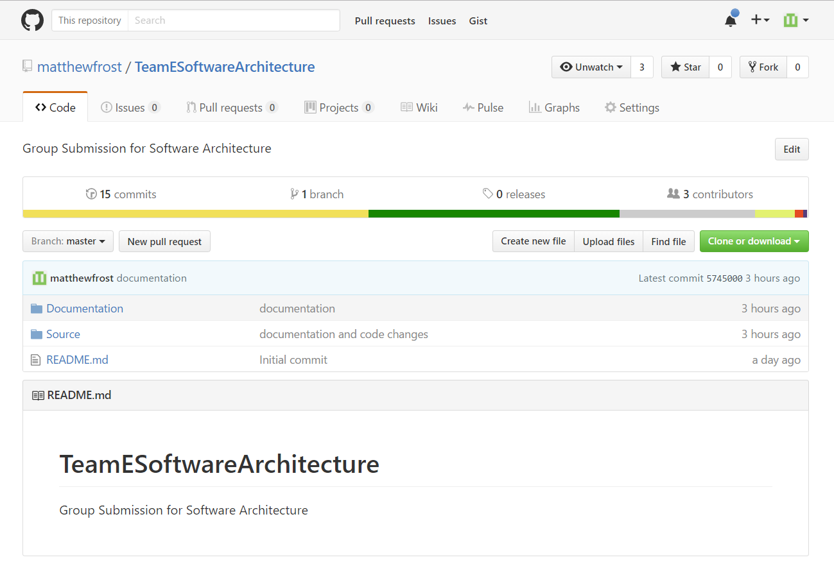

Our repository on GitHub

During the development of the applications we decided to use Git with GitHub as our source control solution of choice. Although we could have also used something like Subversion, no one in our group were familiar with Subversion so Git was the most obvious choice. <https://github.com/matthewfrost/TeamESoftwareArchitecture>